

**Team Member Handbook**

**Hybris E Commerce Implementation @Macmillan**

***Friday, March 03, 2017***

***\*Paper copies are valid on the day they are printed. Online copies can be found at a shared location in SharePoint. Team members are requested to take a printout of this handbook from the portal only.***

**Table of Contents**

1. Project Overview 3

2. Stakeholders 3

3. Communication, Document repository and Calendar 4

4. Hardware and software requirements 6

5. Accessing Macmillan Resources- Gmail, Google Drive, Slack, JIRA and VPN 7

# Project Overview

Macmillan has partnered with Cognizant to implement Hybris E Commerce solution for online selling of its publications. Further details can be found in kick off documents stored in the SharePoint site (refer to section 3 of this document) created for this project. The timeline of this project is depicted below:

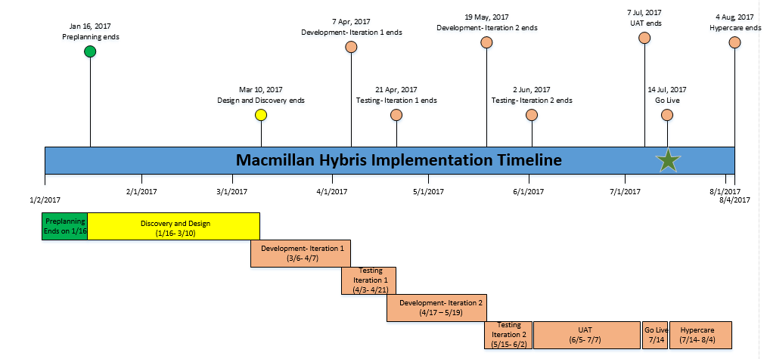

# Stakeholders

**Cognizant’s stakeholders:**

**Onsite:**

1. Onsite Delivery Head- Shyam Thanumoorthy
2. Onsite Program Manager- Sunil Dangwal
3. Onsite Functional Lead- Dinah Rodrigues
4. Onsite Hybris Architect- Pavan Yannam
5. Onsite Hybris Business Analyst- Amit Sharda
6. Onsite Business Analyst- Bala Kiran Kolaganti
7. Onsite Test Lead- Varghese Raju

**Offshore:**

1. Offshore Delivery Head- Pritam Choudhary
2. Offshore Program Manager/ Hybris Architect- Sanjay Roy
3. Offshore Business Analyst- Sachin Madaan
4. Offshore Hybris team members:
   1. Shruti Nomula
   2. Monami Garai
   3. Senthil Kumar R
   4. Thimmareddy K
   5. Pavani Madishetty
5. Offshore Test Lead- Valsala Mithra

**Other Key stakeholders from Cognizant for information purposes:**

1. Nitin Katiyar- Onsite
2. Balaji Sundaram- Offshore
3. Guhan Chandrasekaran- Offshore

**Macmillan’s Key Stakeholders:**

1. Ken Brooks- COO and Project sponsor
2. Alan Pavese- VP, Pricing and a key stakeholder from delivery standpoint
3. Andrew Krenshaw- Systems Integration owner on this project
4. Adrienne Bell- Project Manager from Macmillan
5. ​Sagar Bhujbal- Director of Enterprise Architecture
6. Tim Smith- VP of Architecture and Engineering
7. Utkarsh Akhouri- Manager, Quality Engineering

# Communication, Document repository and Calendar

**Communication:**

Most of the communication which is relevant for the entire team should be sent to the following DL:

[**HybrisMacmillan@cognizant.com**](mailto:HybrisMacmillan@cognizant.com)

The above DL has all the core members on the project. Please copy the other stakeholders separately just in case they are not a part of the DL. If you think you should be a part of the DL and are not currently, please reach out to [Sunil.Dangwal@cognizant.com](mailto:Sunil.Dangwal@cognizant.com) and you will be added within 1 working day.

Also, if the communication is not relevant to the entire team please refrain from sending the emails to this DL.

The team also meets frequently through meetings that are sent on outlook calendars of the team members.

Also, there is a status report that gets published to the DL on a regular basis. Please watch it for high level status, risks and issues in the project.

**Document Repository:**

The team is expected to store the relevant documents on SharePoint site which has been created exclusively for this project. SharePoint URL:

<https://ch1hub.cognizant.com/sites/SC4926/Macmillan%20Ecommerce%20Implementation/SitePages/Home.aspx>

You need to drop an email to Sanjay Roy (Sanjay.Roy2@cognizant.com) to get access to this site.

Please have a look at the following folder structure:

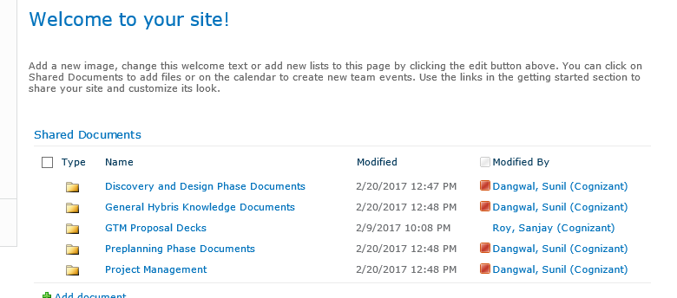

**Discovery and Design Phase Documents:** This folder is used to store all the relevant workshop documents, meeting notes, blueprint and other related documents. There are various subfolders and you should be able to navigate to the right document within those subfolders.

**General Hybris Knowledge Documents:** This folder is used to store all the Hybris related knowledge articles and documents that are otherwise applicable to Hybris and not specific to project in general. Good for people new to Hybris.

**Preplanning phase documents:** This folder has a lot of information around kick-off phase and general structure of the project

**Project Management:** Documents such as trackers, schedules and any information that pertains to Project Management.

It will be helpful if you can set up for receiving notifications on the addition of new documents in the site.

Please note that many documents are also stored in Client’s Google Drive on which you will get more information in section 4 below.

**Calendar:**

Please note that we use SharePoint calendar to notify on important dates for example client holidays, phase dates and individual vacation plan. Kindly update the calendar as and when you are sure of your vacation plan.

Example is below:

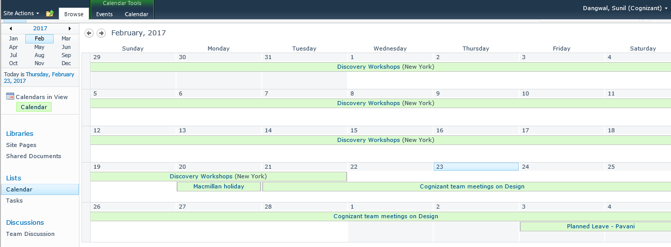

# Hardware and software requirements

**Hardware:**

Please note that Hybris development requires a laptop with the following minimum configuration and it is advisable to secure this configuration as soon as you onboard for this project.

RAM: 16 GB

Processor: i5

If you are at onsite, Sunil Dangwal can help you procure it but do raise a GSD in One NSS portal.

If you are at offshore, please contact Sanjay Roy on how to raise a request. Also, confirm with him if you absolutely need this configuration or can work on your deliverables with a different configuration.

**Software:**

You will need to download Hybris 6.3 EXE from the following location:

<https://drive.google.com/drive/folders/0B82dtXBjrPUhS00wdTZHUTVBWlk?usp=sharing>

How to install Hybris using above .exe, please contact Sanjay Roy at offshore or Pavan Yannam at onsite.

Also, please make sure you get the following software installed on your laptop through NSS

1. Microsoft Project Plan viewer
2. Microsoft Visio

# Accessing Macmillan Resources- Gmail, Google Drive, Slack, JIRA and VPN

In order to access Macmillan resources, the first step is to have a Macmillan email ID/ user name and password. The following steps in sequence would ensure your onboarding:

1. To be done by the resource- Send an email to [Sunil.Dangwal@cognizant.com](mailto:Sunil.Dangwal@cognizant.com) as soon as you are allocated to this project. Sunil will request Macmillan project manager to get the user name established for the new resource.
2. As soon as you are set up, Sunil will let you know your username and password.
3. Macmillan uses Gmail for their corporate email communications. As soon as you get your username and password, please log on to gmail.com with the given user name (in most of the case the user name is [Fristname.Lastname.Contractor@Macmillan.com](mailto:Fristname.Lastname.Contractor@Macmillan.com)) and password. Do not forget to change your password at this time.
4. Once you are logged on to Gmail, you can go to Google Drive and this will give you access to most of the documents that are shared by Client for this project.
5. Slack- Another important communication tool being used at Macmillan is Slack. If you are at offshore, you may not need access to this tool but all the onsite members must use this tool since it is an instant communication tool used at Macmillan. Once Macmillan project manager adds to you to Slack, you will start getting notifications and can even set up your account in Slack.
6. JIRA- Macmillan uses JIRA to track the user stories for this project. The link to JIRA is:

<https://macmillanlearning.atlassian.net/login>.

Kindly use your Macmillan credentials to access JIRA

1. VPN-
   1. Visit URI: <https://vpn.macmillansecure.com/>
   2. Use the DOMAIN/USER ID/PASSWORD

Remember, the domain is NEWYORK and user name is the one supplied by Macmillan (remove@ macmillan.com from your Gmail ID and that is your username. Remember that sometimes for VPN, your user name might not include .contractor e.g. firstname.lastname instead of firstname.lastname.contractor, so please try all the permutations before raising a flag on VPN connectivity)

Web connect provides you limited access to Network resources which should be fine for the project needs. If you need full access to Macmillan Network then use "Network Connect" VPN client.

* 1. If you are still facing any problem in accessing the VPN URL, please use the following URL:

<https://vpn1.macmillanusa.com>

1. Also, as mentioned in the section for document repository, don’t forget to request Sanjay Roy to grant you an access to the SharePoint site.